1.1.5 Student Pass or Fail
Algorithm
- Start
- Read the marks obtained by the student.
- Check whether the marks are greater than or equal to 40.
- If marks ≥ 40, then display “Pass”.
- Otherwise, display “Fail”.
- Stop
Flowchart

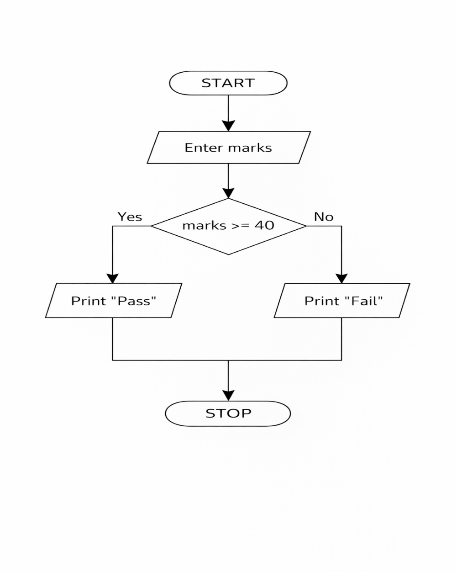
Python code
marks = int(input())
if marks >= 40:
print("Pass")
else:
print("Fail")

EXCECUTION

